User’s Manual

Interrobang

Interactive Puzzle Game

# **‽**

# Installation of Interrobang

## Prerequisites

In order to run Interrobang, the user must have access to an x86_64 based architecture computer with at least 4Gb of RAM, a 1.5Ghz or better processor, and enough room on the hard drive to hold up to 5Gb of content. The system must also be able to run file with a .exe extension. Most modern windows platforms can run these files with no problems. If you have a Mac or Linux based system, look for possible solutions online for running .exe files.

## Download the Game from GitHub

1. Follow this link to the GitHub repository of Interrobang: <https://github.com/JohnHardy5/Interrobang>
2. Download the contents of the repo by clicking the button labeled “Clone or Download” and selecting download zip.
3. The repository will then be downloaded as zip folder to your “downloads” directory.
4. Open the “downloads” directory using the file management software for your operating system and unzip the folder in location that you want the game to run in.
5. You have successfully downloaded Interrobang! Note that the only files you actually need to run the game are contained in the “Build” folder, all other files can be deleted if you do not wish to modify the game yourself.

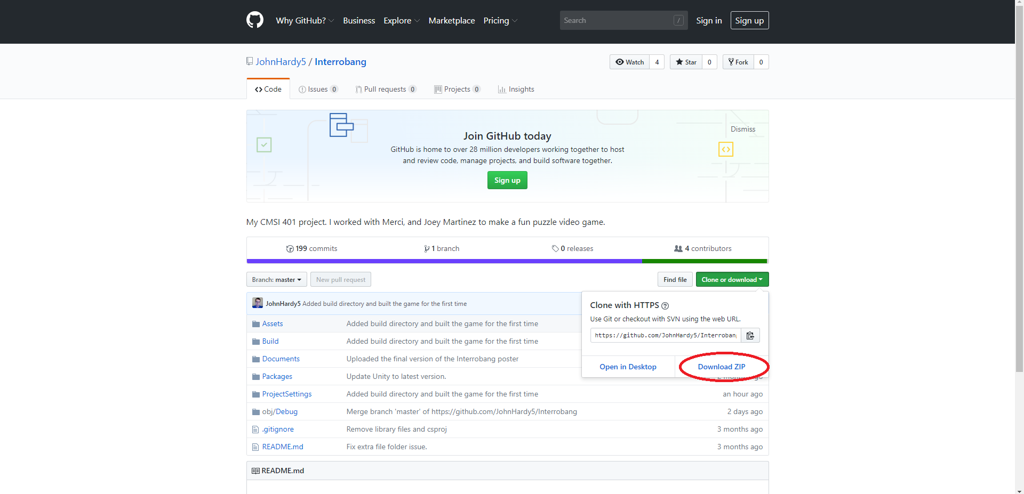

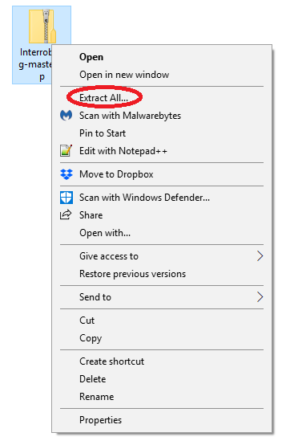

# Running Interrobang

1. Using your file management software, navigate your filesystem to the directory that contains the unzipped Interrobang folder.
2. Open the Interrobang folder.
3. Open the Build folder.
4. You should see a bunch of files that are used as libraries to run the game. Notice the file named “Interrobang.exe”.
5. Run the file by double-clicking on it or by selecting it and choosing the option to run the file.
6. Interrobang will start running on your system.
7. If everything works correctly, you will be presented with a window that gives you options for keyboard input layouts, resolution and windowed vs. non-windowed mode.
8. Click “play!” when you are ready to play the game.

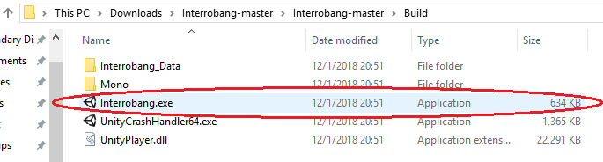

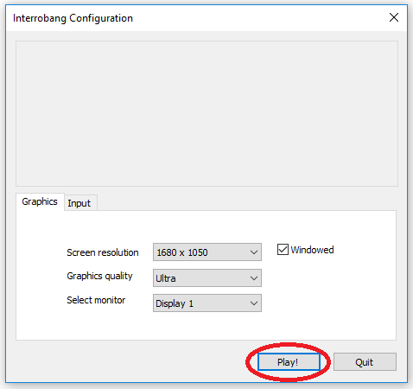

# Stopping Interrobang

1. If the game is currently in the start menu, press the “QUIT” button to close the game.
2. If the game is not in the start menu, press the “escape” key to open the escape menu.
3. Press the “QUIT” button in the escape menu to close the game.

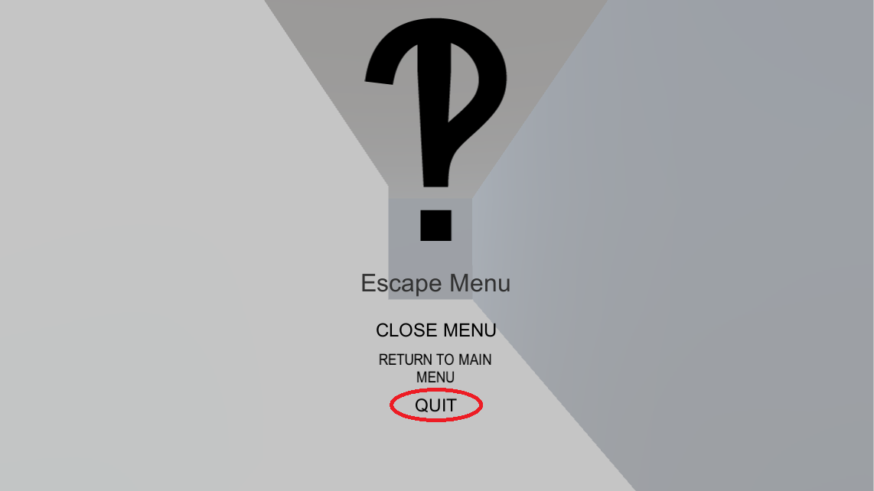

# Uninstallation of Interrobang

1. Navigate to the directory in you filesystem that contains the “Interrobang” folder.
2. Select the Interrobang folder without opening it.
3. Click the “delete” key on your keyboard, or right click on the folder and select “delete”.
4. If you are presented with a confirmation window, select the affirmative option to delete the folder.

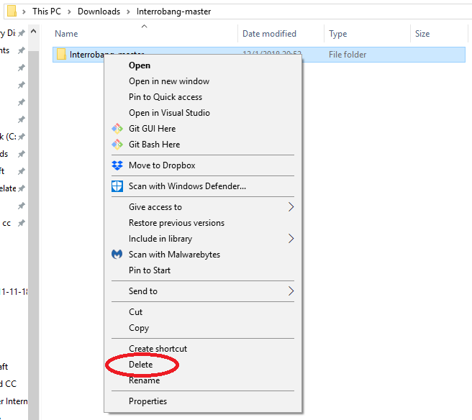

# How to Play Interrobang

## Overview

For anyone who has played any sort of 3D game before with a keyboard and mouse, learning how to play Interrobang will come quickly to them. Those with little to no exposure to such video games, learning how to play Interrobang will be very difficult as the game requires the user to have significant hand-eye coordination to play well.

## Keyboard Manipulation

The default keyboard layout for Interrobang is as follows:

* The “W” key is used to move the player **forward** in the direction the camera is pointed.
* The “A” key is used to move the player **left** of the direction the camera is pointed.
* The “S” key is used to move the player **backwards** of the direction the camera is pointed.
* The “D” key is used to move the player **right** of the direction the camera is pointed.
* The “Shift” key is use to increase the player’s movement speed while the user holds the button down. The moment that the key is release, the player’s speed is reduce. Note that this will still work as normal even while the player is traveling through the air.
* The “Space bar” is use to jump the player. The player cannot jump while they are in the air.

**NOTE:** The default keyboard layout for Interrobang can be changed using the initial start-up window presented to the user before playing the game.

## Mouse Manipulation

The mouse is used to manipulate the player’s camera and controls what the user sees on the screen.

* Moving the mouse *forward* will move the camera so that it is pointed **upward**.
* Moving the mouse *left* will move the camera so that it is pointed **left**.
* Moving the mouse *backward* will move the camera so that it is pointed **downward**.
* Moving the mouse *right* will move the camera so that it is pointed **right**.

**NOTE**: The camera is designed so that the player cannot look behind themselves without turning their entire body. In other words, the player is not able to look over their shoulder or tilt their head completely backwards. If the camera is moved too far upward or downward, it will reach a point where it will no longer move any further in that direction.

## Interactions with the Level

The three main things that the player can do are:

* Jump onto Platforms: There are multiple types of platforms such as static non-angled platforms, static angled platforms, and moving platforms. All static platforms will hold the player in midair regardless of angle. All moving platforms will carry the player along its designated path of movement.
* Press Buttons: If the player stands over a button in the level, the button will be depressed and will trigger an event somewhere in the level. Note that pressing the button multiple times may or may not create special interactions with the world.
* Hit Spikes: If the player touches a spike at any point during the game, they will “die” and will be teleported back to the most recent spawn location that they reached in the world. Keep in mind that spawn locations are hidden in hallways and are invisible to the player. **NOTE:** there is a known bug in the game where the player becomes “invincible” to spikes and does not die when they touch them. If this happens while you are playing the game, it is recommended to restart the game in order to get the best experience out of the game.

# Troubleshooting

## Installation Problems

* If you are having difficulties with unzipping the game, consider googling a step-by-step guide on how to unzip a file from the “downloads” directory.
* If you are having difficulties downloading the game, ensure that you have an active internet connection and that your firewall is not blocking your access to Github.com. Note that some systems have limitations on them that do not let you download content from the web.

## Problems Running the Game

* The most common reason that someone is unable to run Interrobang is that their operating system does not support .exe files (common in Mac OS and Linux based computers). It is recommended to run the game on a Windows based computer in order to run the .exe file for the game.
* If the game does not start properly, ensure that all of the files in the build folder on the GitHub repository match the files in the build directory in your filesystem. It is not uncommon for us to push patches to fix bugs in the game that require the user to download the game again.

## Problems Stopping the Game

* Sometimes, if the computer runs out of memory or processing power to run the game it will “freeze” and stop responding to inputs given by the user. If this happens to you and the game continues to not respond after a couple of minutes, try using the task manager or process manager in your system to manually shut down the program. In windows this can be done with “ctrl + alt + del”.

## Problems Uninstalling the Game

* Note that this problem only occurs if the user unzipped the Interrobang folder into a directory that is protected from deletion operations (i.e. unzipping into the root directory of the C: drive). To delete the game files in this situation, the user will need to login to the computer as an administrator, navigate to that directory using the file management software, and delete the folder using administrator privileges.

## Problems Playing the Game

* Keep in mind that this game is still very underdeveloped and may contain significant bugs in it. If you encounter one of these bugs, it is recommended that you restart the game in order to get the best experience possible. Please report these bugs to any of the game developers in the contact information section of this document.
* A currently well-known bug in the game prevents the player from dying when they touch spikes in the level. If this occurs while you are playing the game, please restart the game as spike interaction is one of the main features of the game.

# Contact Information

Lead Software Designer: Joey Martinez ([joeymichaelmartinez@gmail.com](mailto:joeymichaelmartinez@gmail.com))

Lead Software Developer: John Hardy ([jhardy5@lion.lmu.edu](mailto:jhardy5@lion.lmu.edu))

Lead Art Designer: Merci Magallenes ([mmagall5@lion.lmu.edu](mailto:mmagall5@lion.lmu.edu))